A

RESEARCH

ON

**“SMART GARBAGE FILL SYSTEM** **(SMARTBIN)”**

SUBMITTED BY

**ANJALI DATTA PATIL**

UNDER THE GUIDANCE OF

**MRS. KAISHA TALREJA**

SUBMITTED IN PARTIAL FULFILLMENT

OF REQUIREMENT FOR QUALIFYING

**B.Sc. COMPUTER SCIENCE SEMISTER-VI**

**MARCH 2020**

**B.K BIRLA COLLEGE OF ARTS, SCIENCE & COMMERCE (Autonomous), KALYAN (W)-421304**

**ACADEMIC YEAR 2019-2020**



|  |  |  |
| --- | --- | --- |
| **CERTIFICATE** | | |
|  | | |
|  | | |
| This is to certify that the project entitled ____________________________________________________ | | |
|  | | |
| submitted by ____________________________________ , Seat No. ___________ is record of project work | | |
|  | | |
| carried out by him/her , under my guidance, in partial fulfillment of the requirement for the award of the Degree  of B.Sc. in Computer Science of University of Mumbai. | | |
| Date : | | |
| Place : | | |
|  | | |
|  | | |
|  | | |
|  | | |
|  | | |
|  | | |
| Internal Project Guide | Signature of  External Examiner | Head of Department  Computer Science |
|  | | |
|  | | |
|  | | |
|  | | |
|  | | |

**ACKNOWLEDGEMENT**

I gratefully acknowledge for the assistance, cooperation, guidance and clarification provided by during the development of the Student fees management system project.

It is a pleasure to express my deep and sincere gratitude to project guide “Mrs. Kaisha Talreja” and the profoundly grateful towards the unmatched help rendered by her.

I would like to thank our Head of the department “Mr.Vinod Rajput” for his blessings and for being a constant source of inspiration to us. I am also thankful to all the professors for making their valued contribution and for providing a helping hand to us in times of queries and problems.

I would also thank my friends for giving me the opinions and various inputs in long discussion on the project which helped me shape the project keeping in mind the user friendly.

I would also like to thank everyone helped me in my project in some way or other which includes providing me with some information.

**ABSTRACT**

In the recent decades, urbanization has increased tremendously. at the same phase there is an increase in waste production. waste management has been a crucial issue to be considered. So, to overcome this issue i have taken web survey on the current waste management system to know that which problems people are facing. Based on result of that survey i have decided to implement my idea of the smart bin.People throw garbage in dustbin (garbage collection) with the ultrasonic sensor in top of the garbage bin and then this sensor will check that whether the dustbin is full or not that means it will check that the garbage is reached at condition level or not. If it reaches to that level that means if it is full then this sensor will send message to the control room/authority to control or to collect this waste and if the dustbin is not full it will repeat this procedure again. Then the control room will send cleaning vehicles for cleaning and they will update the status of the dustbin and process will repeat again.

**KEYWORDS:** Dustbin, Microcontroller, GSM , Arduino ,Sensors

**Problem statement:**

To implement a smart bin built on a microcontroller based platform Arduino Uno board which is interfaced with GSM modem and Ultrasonic sensor which can gives the status of the waste present in the dustbin to the municipal authority.

**INTRODUCTION**

In this papersmart garbage fill system (smart bin) is built on a microcontroller based platform Arduino Uno board which is interfaced with GSM modem and Ultrasonic sensor. Ultrasonic sensor is placed at the top of the dustbin which will measure the stature of the dustbin. The threshold stature is set as 10cm. Arduino will be programmed in such a way that when the dustbin is being filled , the remaining height from the threshold height will be displayed. Once the garbage reaches the threshold level ultrasonic sensor will trigger the GSM modem which will continuously alert/Notify the required municipal authority until the garbage in the dustbin is squashed. Once the dustbin is squashed, people can reuse the dustbin. At regular intervals dustbin will be squashed. Once these smart bins are implemented on a large scale, by replacing our traditional bins present today, waste can be managed efficiently as it avoids unnecessary lumping of wastes on roadside. Foul smell from these rotten wastes that remain untreated for a long time, due to negligence of authorities and carelessness of public may lead to long term problems. Breeding of insects and mosquitoes can create nuisance around promoting unclean environment. This may even cause dreadful diseases.

**SURVEY ON CURRENT WASTE MANAGEMENT SYSTEM:**

1. Name
2. Short Address / Location
3. Do you have regular garbage collection (Dustbin) in your area?

* Yes
* No

1. Do you use it?

* Yes
* No

1. How often do you use the garbage collection service?

* Once a week
* Other

1. Do you separate different type of waste at your home?
   * Yes
   * No

**7)** Are you satisfied with your current waste management/collection system?

* Yes
* No

1. What is the main reason for your level of Dissatisfaction?

* Improper collection
* Cost
* Smell
* Unreliability
* Not Cooperative
* Other

9) Do people d ump their waste alongside the garbage bins instead of putting it inside?

* Yes
* No

10) Why in your opinion people behave like this?

* waste spread around the bin
* height of the bin
* Want to do like others
* Laziness
* Habit
* Other

11) Do you have any problems with this situation (Garbage alongside if the bin)?

* Yes
* No

12) Please identify some of the main problems with the current waste management system.

* Waste lying around
* Odur
* Pollution
* Damage to the Environment
* Other

13) To overcome this situation are you ready to use Smart waste management system?

* Yes
* No

14) Based on this Questions and situation of your society related to the waste or garbage please give your opinion or suggestions.

**RESPONSE:**

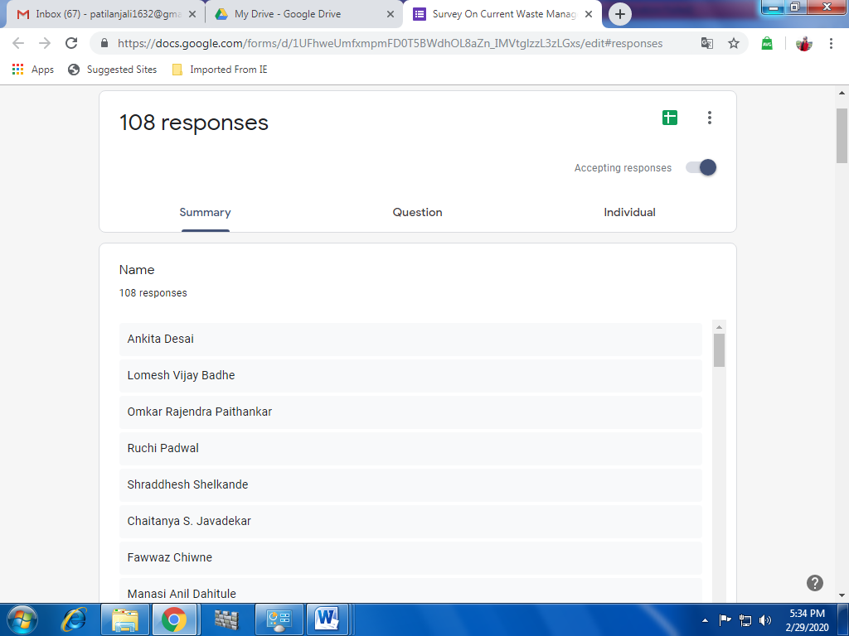

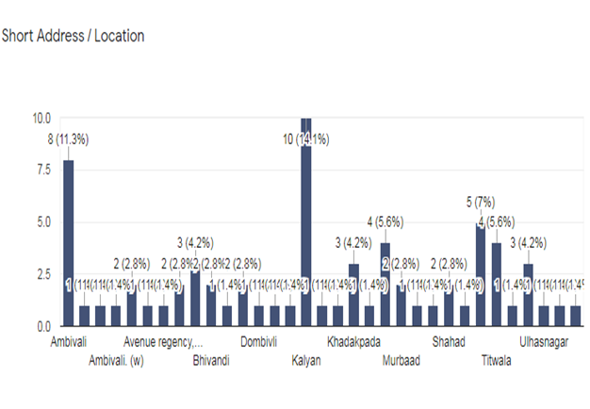

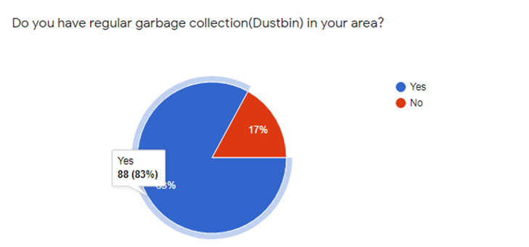

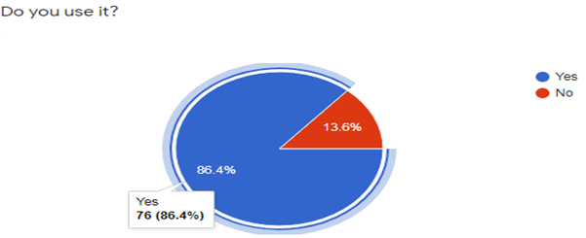

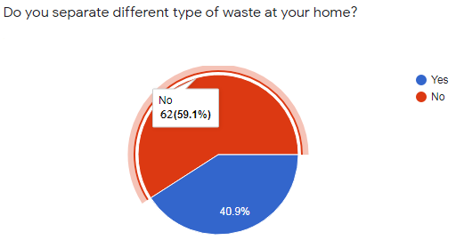

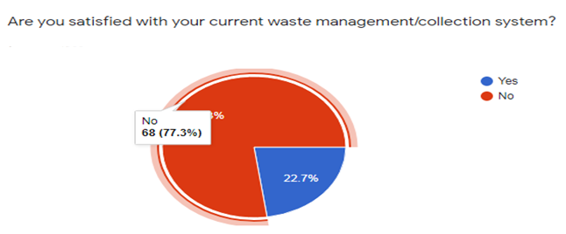

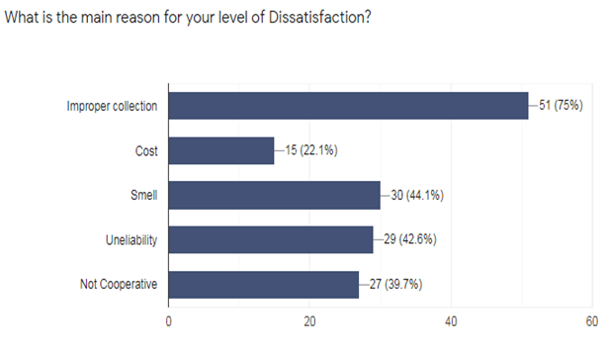

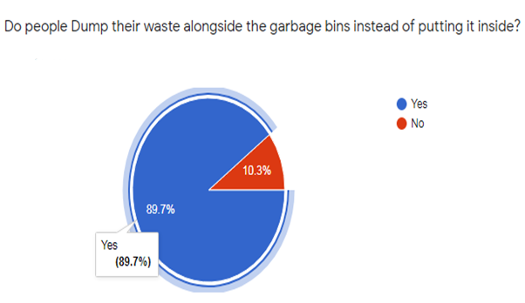

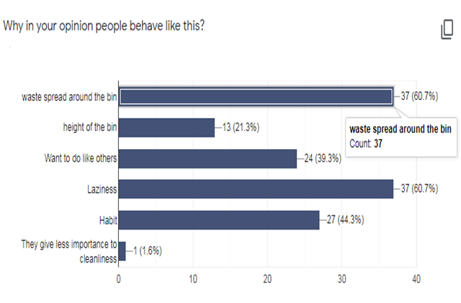

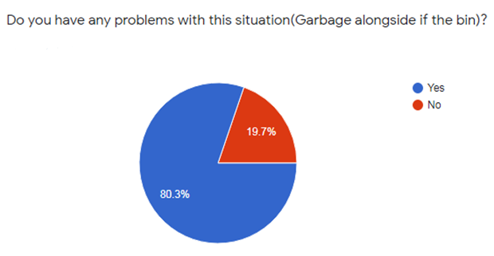

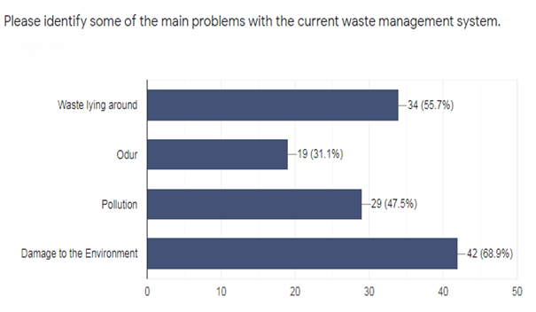

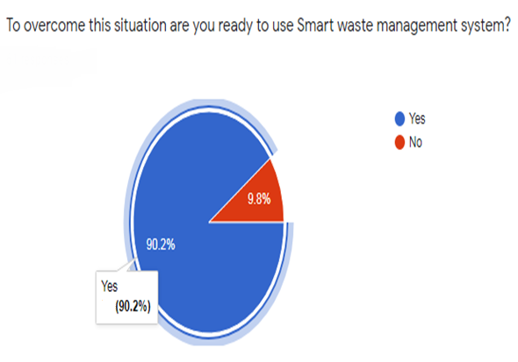

**SYSTEM DESIGN**

For communication purpose Bluetooth technology can also be used in the transmitter section. Bluetooth is a wireless networking standard that is aimed at remote control and sensor applications which is suitable for operation in harsh radio environments and in isolated locations. But, the main disadvantages of Bluetooth is short range, low complexity, and low data speed. Therefore, GSM is more advantages over Bluetooth for communication.

A GSM modem is a specialized type wireless modem that works with a GSM wireless network. These GSM modems can be used for sending and receiving SMS and MMS message. GSM Modem sends and receives data through radio waves. In this project we are using GSM modem for the communication.

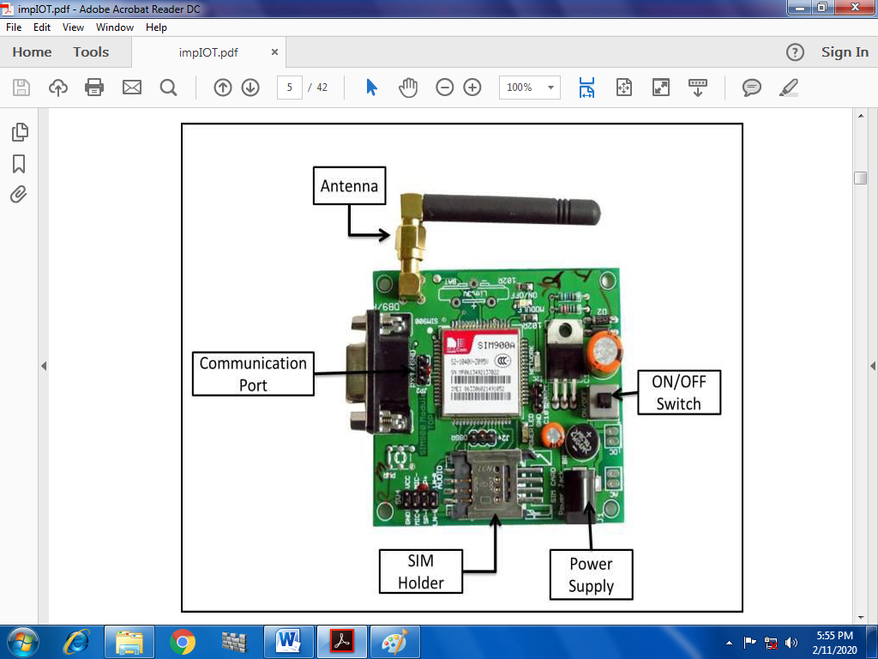

**Fig. GSM**

**Transmitter Part from Dustbin:**

Below figure shows the block diagram of transmitter section. Level detector consists of IR sensors which is used to detect the level of the garbage in the dustbin. The output of level detector is given to microcontroller. IR sensors are used to indicate the different levels of the amount of the garbage collected in the dustbin which is placed in public area. When the dustbin is filled up to the highest level, Then this output is given to microcontroller to send the message to the Control room via GSM module as shown in below.

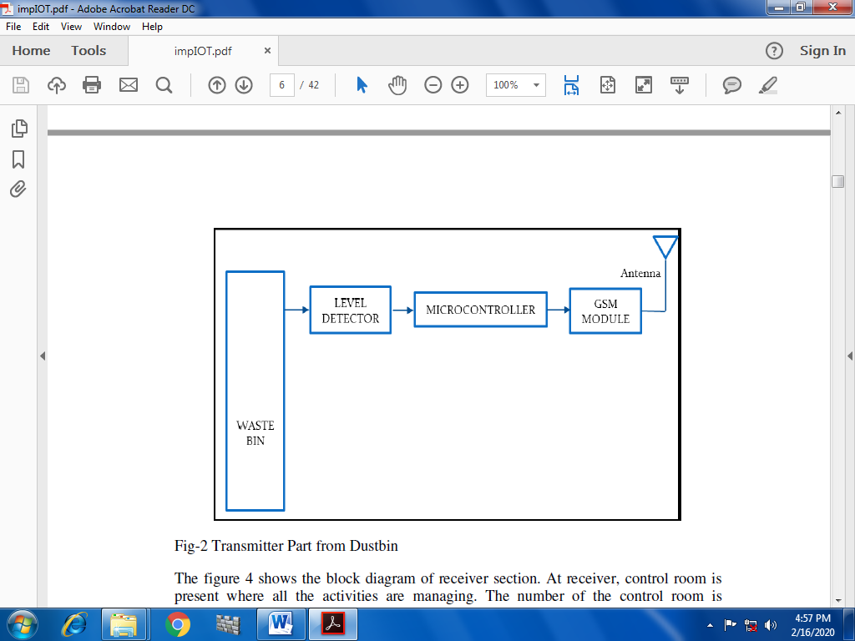

Fig. Transmitter Part from Dustbin

**Reception Part to Dustbin:**

The below figure shows the block diagram of receiver section. At receiver, control room is present where all the activities are managing. The number of the control room is depending on the dustbins present in the area. The person sitting in the control room monitors the entire system. A GSM Module is connected to the computer of the control room through microcontroller. The entire system is monitor by the person sitting in the control room. The same GSM Module is used to send the message to the contractor for cleaning the dustbin. This GUI will be displayed on the computer screen in the control room to display the status of the garbage level in the dust bin as shown in below.

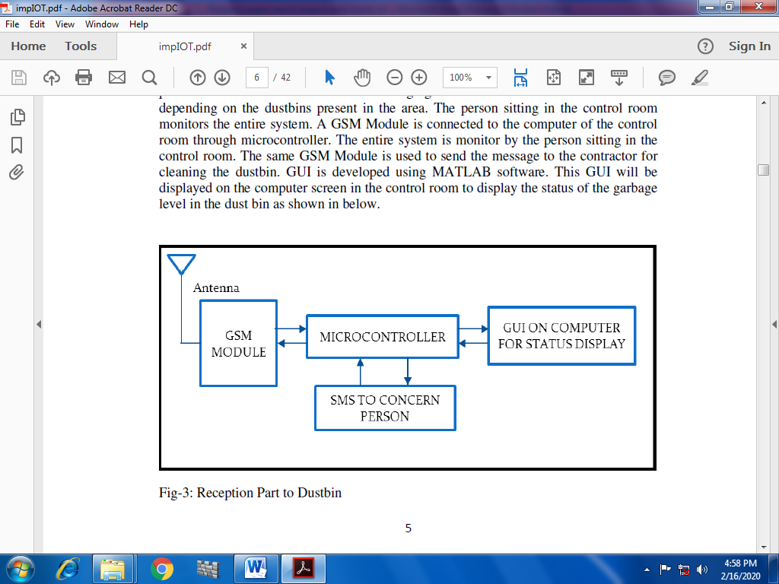

Fig. Reception Part to Dustbin

**Flowchart of Working Principle:**

Check whether dustbin is full=?

Send msg to a control room/Authority

Send cleaning vehicle for cleaning

Update status of dustbin

No

Yes

Fig.Flowchart

Dustbin placed in public place and ultrasonic sensors are place at the top of the garbage bin when people throw garbage in dustbin at that time this sensor will check whether the dustbin is full or not that is it will check that the garbage is reached at condition level or not. If it reaches to that level that means if it is full then this sensor will send message to the control room/authority to control or to collect this waste. Then the control room will send cleaning vehicles for cleaning and they will update the status of the dustbin and process will repeat again. If the dustbin is not full it will repeat this procedure again.

**REQUIREMENT SPECIFICATION:**

**Components used-**

* Arduino
* GSM
* PIR Sensor
* Ultrasonic Sensor
* Breadboard
* Connecting wire

**1) Arduino:**

Arduino is an open source, computer hardware and software company, project, and user community that designs and manufactures microcontroller kits for building digital devices and interactive objects that can sense and control objects in the physical world. Arduino boards are available commercially in preassembled form,

or as do-it-yourself kits. Arduino board designs use a variety of microprocessors and controllers. The boards are equipped with sets of digital and analog input/output (I/O) pins that may be interfaced to various expansion boards (shields) and other circuits.

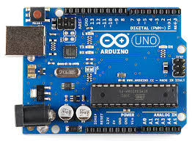 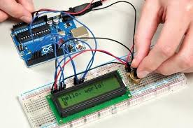

Fig. Arduino

**2) GSM (Global System for Mobile Communication):**

GSM Modem can accept any GSM network operator SIM card and act just like a mobile phone with its own unique phone number. Advantage of using this modem will be that you can use its RS232 port to communicate and develop embedded applications. Applications like SMS Control, data transfer, remote control and logging can be developed easily using GSM. The modem can either be connected to PC serial port directly or to any microcontroller. It can be used to send and receive SMS or make/receive voice calls.

**3) PIR sensors:**

PIR sensors allow you to sense motion. They are used to detect whether a human has moved in or out of the sensor’s range. They are commonly found in appliances and gadgets used at home or for businesses. They are often referred to as PIR, "Passive Infrared", " Pyroelectric", or "IR motion" sensors.

Following are the advantages of PIR Sensors −

* Small in size
* Wide lens range
* Easy to interface
* Inexpensive
* Low-power
* Easy to use
* Do not wear out

PIRs are made of pyroelectric sensors, a round metal can with a rectangular crystal in the centre, which can detect levels of infrared radiation. Everything emits low-level radiation and the hotter something is, the more radiation is emitted. The sensor in a motion detector is split in two halves. This is to detect motion (change) and not average IR levels. The two halves are connected so that they cancel out each other. If one-half sees more or less IR radiation than the other, the output will swing high or low.

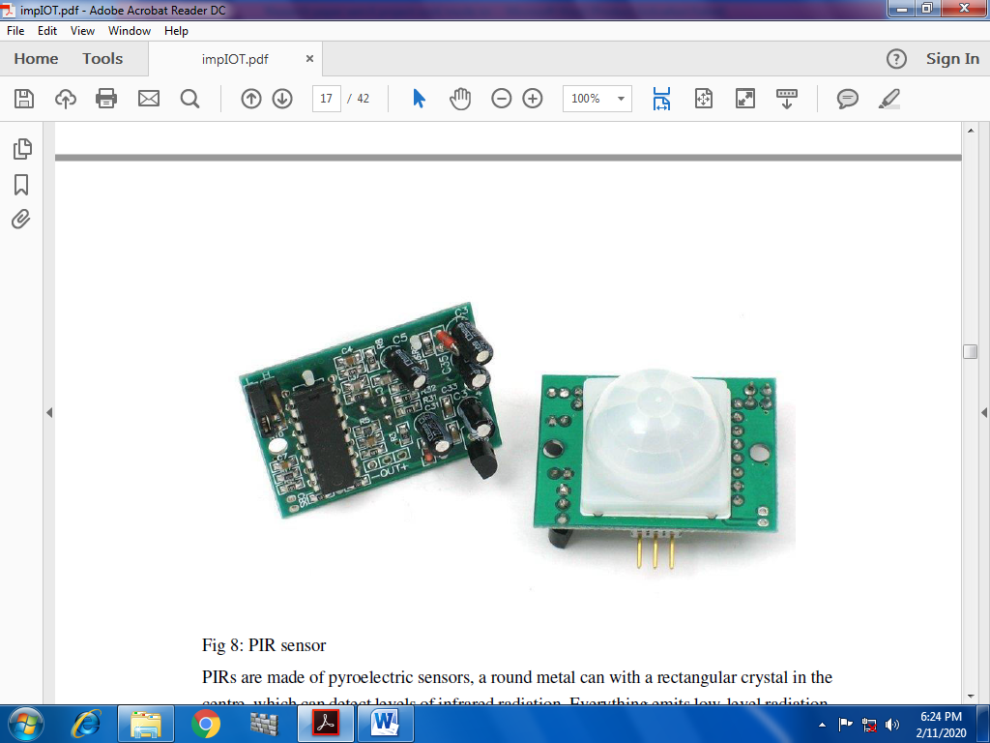

Fig. PIR sensor

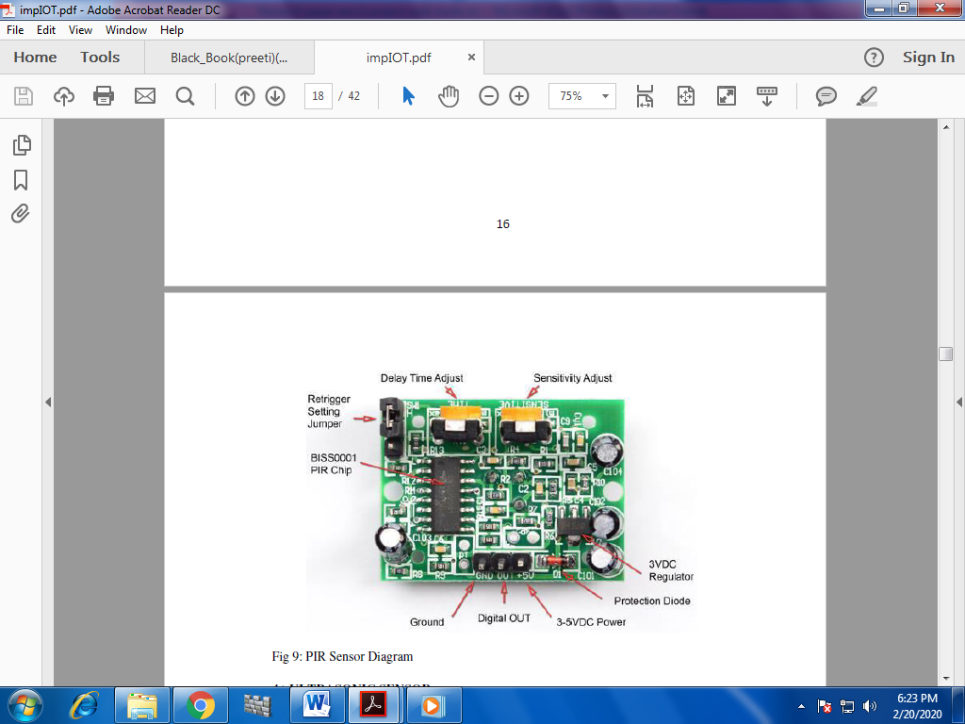

Fig.PIR Sensor diagram

**4) Ultrasonic Sensor:**

TheHC-SR04 ultrasonic sensor uses SONAR to determine the distance of an object just like the bats do. It offers excellent non-contact range detection with high accuracy and stable readings in an easy-to-use package from 2 cm to 400 cm or 1” to 13 feet. The operation is not affected by sunlight or black material, although acoustically, soft materials like cloth can be difficult to detect. It comes complete with ultrasonic transmitter and receiver module.

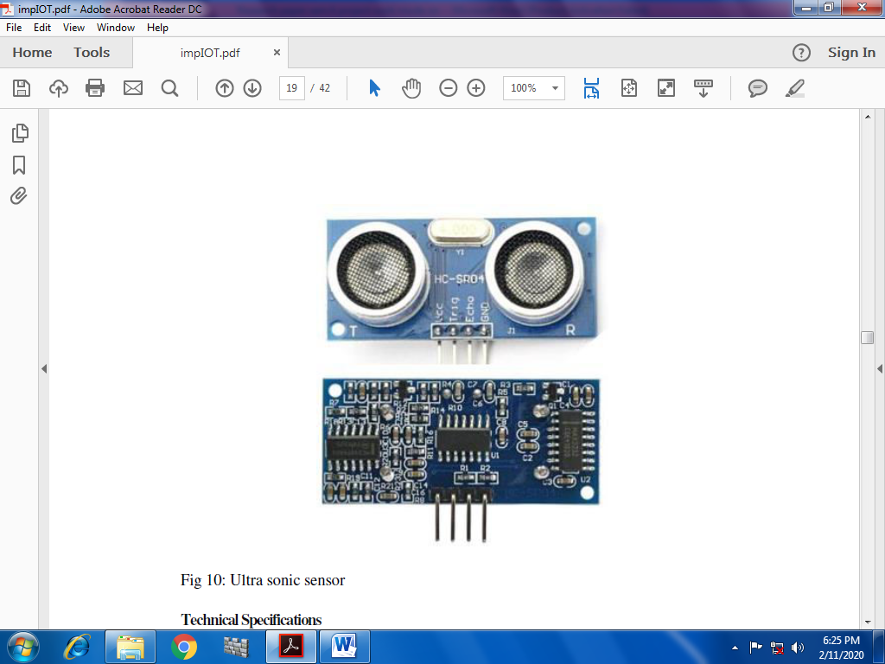

Fig. Ultrasonic sensor

**5)Breadboard:**

A breadboard is a construction base for prototyping of electronics. Originally it was literally a bread board, a polished piece of wood used for slicing bread. Because the solderless breadboard does not require soldering, it is reusable. This makes it easy to use for creating temporary prototypes and experimenting with circuit design. For this reason, solderless breadboards are also extremely popular with students and in technological education. Older breadboard types did not have this property. A stripboard (Vero board) and similar prototyping printed circuit boards, which are used to build semi-permanent soldered prototypes or one-offs, cannot easily be reused. A variety of electronic systems may be prototyped by using breadboards, from small analog and digital circuits to complete central processing units (CPUs).

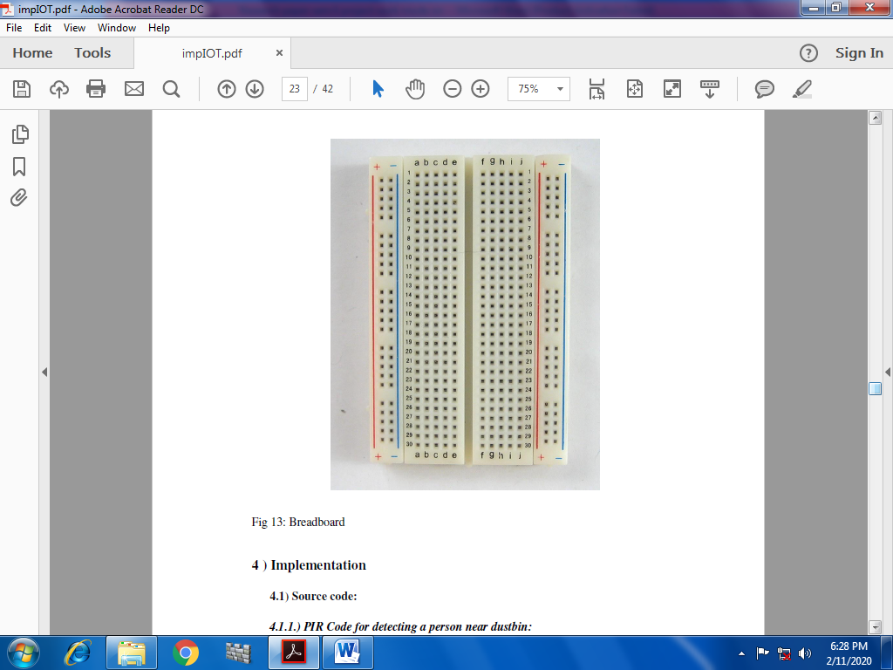

Fig.Breadboard

**CONCLUSION**

This project is for Smart Garbage Fill Alerting system using Ultrasonic sensor, Arduino Uno, Buzzer and Wi-Fi module. This system assures the cleaning of dustbins soon when the garbage level reaches its maximum .If the dustbin is full then this system will send message to the authority to clean up that garbage bin. This reduces the total number of trips of garbage collection vehicle and hence reduces the overall expenditure associated with the garbage collection. It ultimately helps to keep cleanliness in the society. So because of cleanliness many of the problems like Waste lying around, dirty smell, Pollution ,Damage to the Environment can be reduce. Therefore, the Smart Garbage Fill Alerting system

(Smart bin) makes the garbage collection more efficient.

**FUTURE ENHANCEMENT**

Automatic Garbage Fill Alerting system helps us to reduce the pollution. Many times garbage dustbin is overflow and many animals like dog or cow enters inside or near the dustbin. Also some birds are also trying to take out garbage from dustbin. This project can avoid such situations. And the message can be sent directly to the cleaning vehicle instead of the contractor’s office. Apart from this, differentiation can be made between dry trash bin and wet trash bin collecting plastic dry waste and biodegradable waste respectively. To enhance it further, an automated system can be developed which is able to pick up waste in and around the bin, segregate them and put them in respective bins.